**Article ID:** 500 New a

**Article Name:** [1173] Check drain

**Topic Location:** Laundry / Washing Machine/ Water / Emptying / Draining

**Meta-data:** empty, pump out, flow out, remove, pump of

**Related Articles:** Check and clean filter

**Related Questions:**

PNC

DIY

Safety

Link

Email

Book Engineer

Multimedia

Brand

**Article Content:**

**WARNING** - Switch the appliance off and unplug it from power supply before you carry out any cleaning or maintenance.

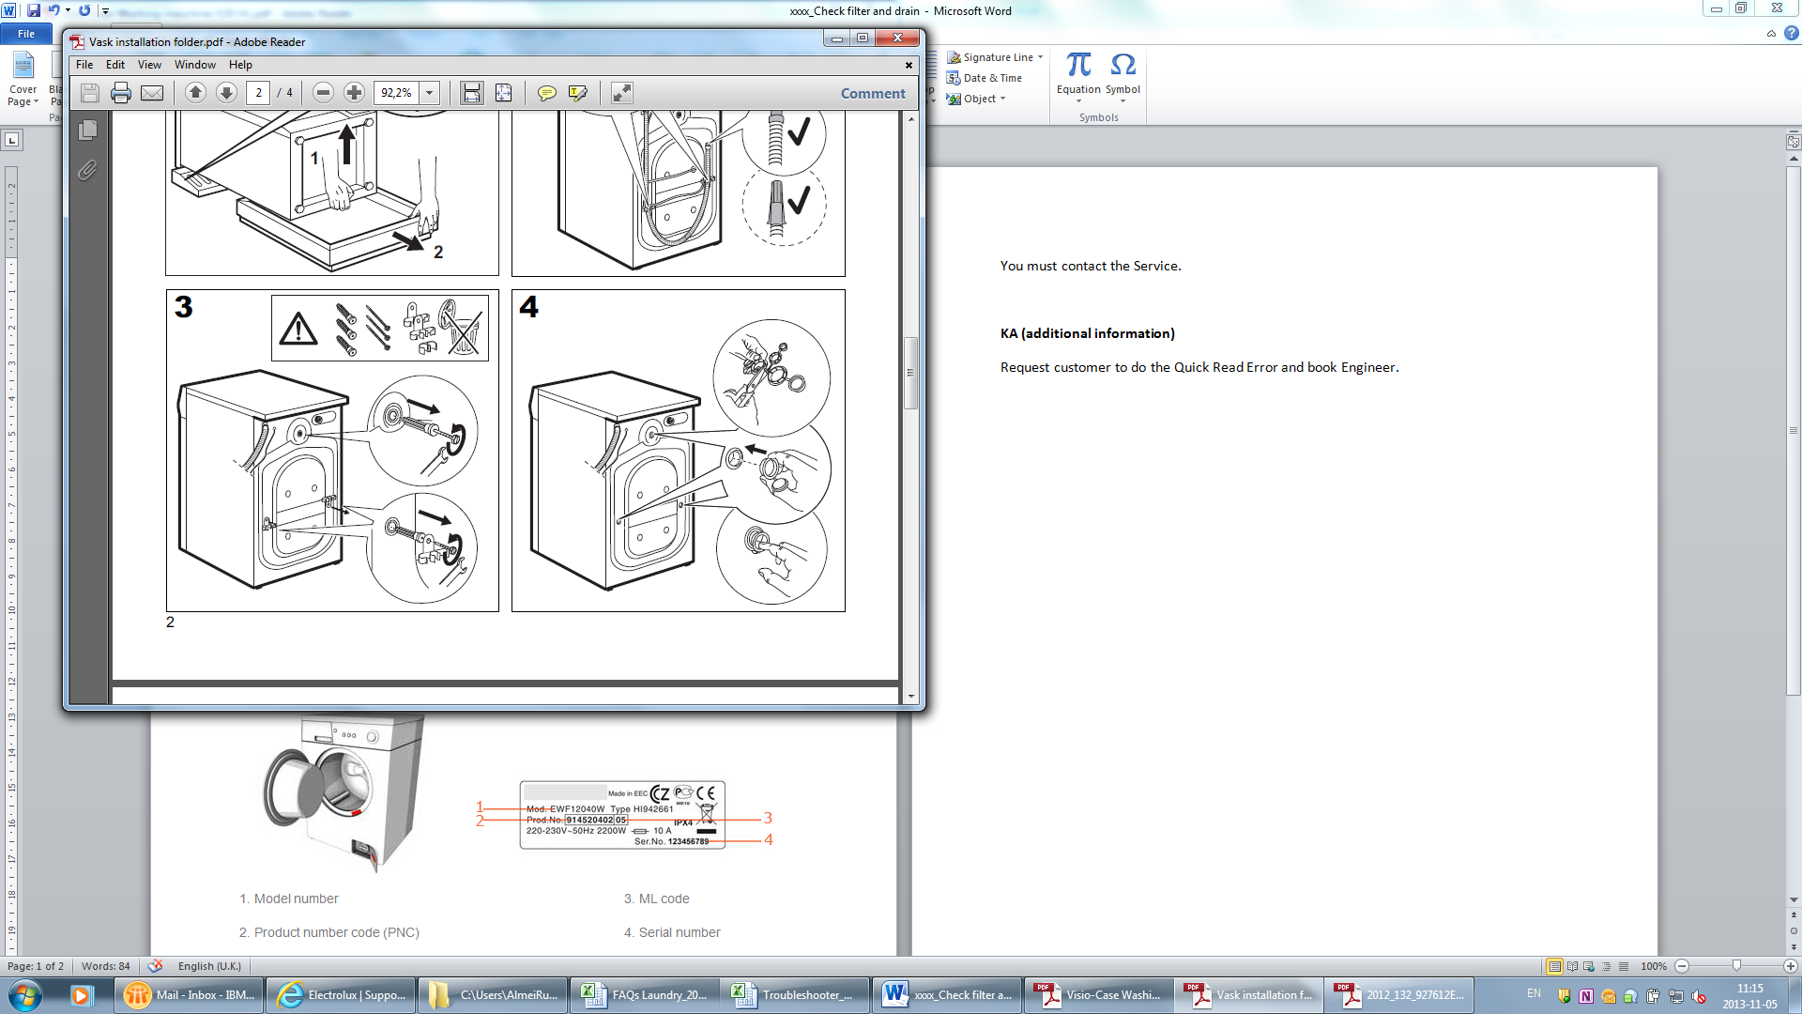

Check if the drain hose is properly installed. And that is not bent, twisted or distorted.

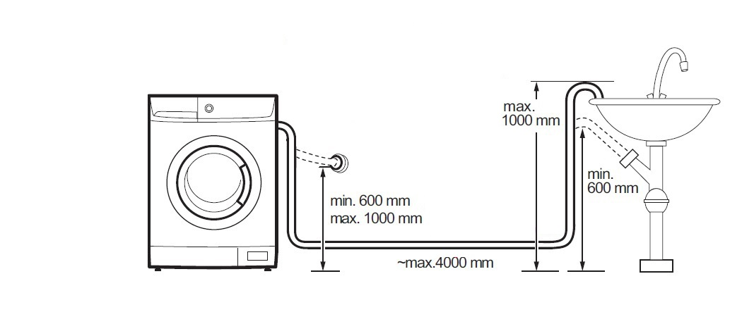

In case of new installation or reinstallation confirm that the Blanking plug was removed!

If the installation is correct [check and clean the drain filter](1132_Check%20filter.docx).

[Find the specific User Manual for the washing machine.](http://www.electrolux.co.uk/Support/Manuals/)

To clean internal parts we recommend you to do following:

Run a number of wash cycles at 90°C, without any laundry, but with a cup of sodium carbonate (Sodium carbonate irritates skin and mucous membranes. Please use it with extreme caution!) in the drum, to clean the seal.

Or you can use our special Electrolux cleaner for washing machines:

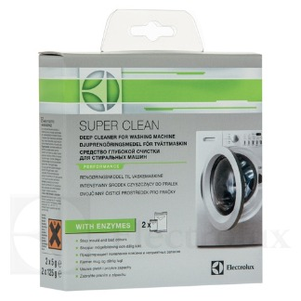

To buy this cleaner please follow the link to our webshop:

<http://shop.electrolux.co.uk/product/9029792786/Super-Clean+Washing+Machine+Cleaner>